**Instructions to run the KV Food Delivery Service App:**

Before running the application, please take a minute or two to understand the basic menu options first.

To skip this part, please proceed to page 2.

*For general questions regarding app usage if instructions found to be unclear; please feel free to reach me at sozoalvin@gmail.com*

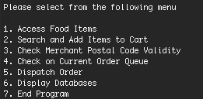

1. **Access Food items**

This menu option shows you all the food options that are available. It’s more of an option that allows a user to browse for all available food items imported from the database. No other functions can be found in this menu.

1. **Search and Add items to Cart**

Accessing this menu opens up the world of possibilities. You can search for an item; and thereafter add them to cart and checkout on orders leading to queues.

1. **Check Merchant Postal Code Validity**

Use this feature to check if a certain merchant is registered at any postal code

1. **Check on Current Order Queue**

This allows the user to view the current queue. It shows the list of queues etc.

1. **Dispatch Order**

This allows a Queue to be removed from the system, emulating a real scenario where a delivery partner/ rider has already agreed to commit in fulfilling the order.

1. **Display Databases**

Accessing this menu allows you to view two types of databases. You will be able to view databases that are organized by transaction IDs and usernames.You will also have an option of exporting them to json files.

1. **End Program**

**Start Using the Program**

1. To start the program, please *cd* into the right directory where you have unzipped the files.

*go run main.go database.go databaseMaps.go mainFunctions.go messageTemplates.go queueManagement.go rawData.go*

1. Enter the above code into your terminal and press Enter

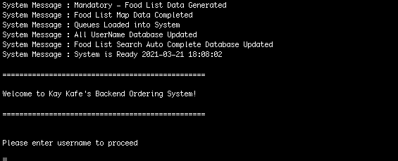

1. If all the data is initialized correctly, you should observe **6** different system messages and the welcome message.
2. You can log in using the username **admin** . There is no password verification that has been implemented in this prototype app.

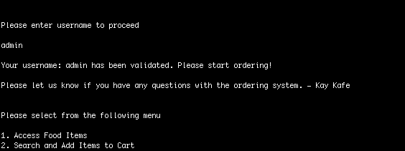

1. Menu 1 will give you a list of food items for you to browse. You may wish to go into Menu 2 directly

1. Type 2, and press Enter and you’ll be brought to a search screen. You can search for anything you like. But for the purpose of this guide. We’ll be searching for c. c used here, is a small case c.

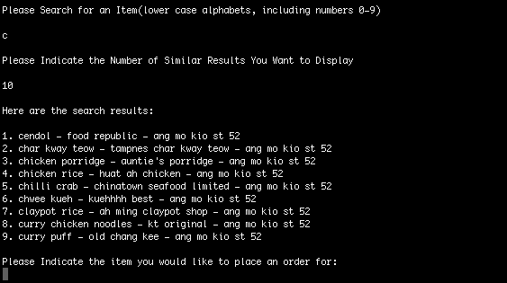

1. After typing the first alphabet, you can press enter and the program will continue by asking you for the number of search results that you want.
2. Please proceed by choosing the number of search results you wish to display. We use 10 in the example above. In a big database, it will be useful to limit the number of queries to prevent overloading the system.
3. Choose your favorite dish. In this case, we really like Singapore’s famous dish - chilli crab so we’re going to input option 5.

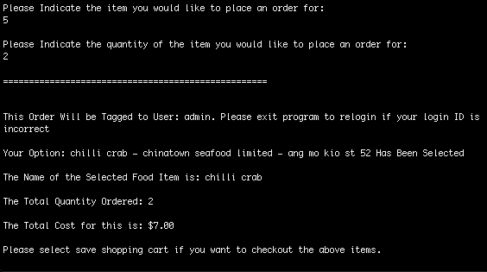

1. Along with that, we’re also going to tell the program that we want to order 2 of it.
2. If the inputs are correct, you should be shown a screen with regards to your selected dish name, it’s address, the total quantity ordered as well as the total price.

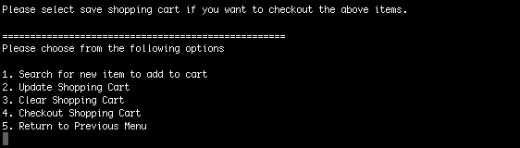

1. Please select 2 to update your shopping cart. This emulates the Add to Cart Button in an ecommerce website. In other words, add to cart functionality is not automatic. Not updating the cart means whatever that is selected will be lost once a new search is conducted.
2. You may continue adding more items into your cart by selecting option 1 to search for items again. Otherwise, please feel free to checkout (option 4) the items. If you think you’ve made a mistake, you can also clear the cart by selecting option 3.
3. Other words you can try searching for include the letters m, s, r, and h.
4. Once you’re ready, you can checkout with option 4. If you did log in with the username ‘admin’ , you will see the following prompt regarding service recovery

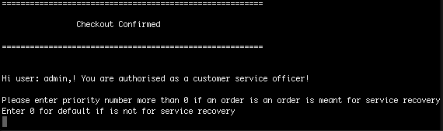

1. If the order is meant for a service recovery effort, please enter any number above 8.

9 would be a good choice. Hit Enter and this order will be processed with a proper queue number generated in the system

*The system is preinitiated with dummy data that has a queue-ed item with highest priority value at 7. Putting an order with priority value 8 will push it right to the top; as opposed to being right at the back like a regular queue structure.*

1. You can view the current queue by selecting option 4

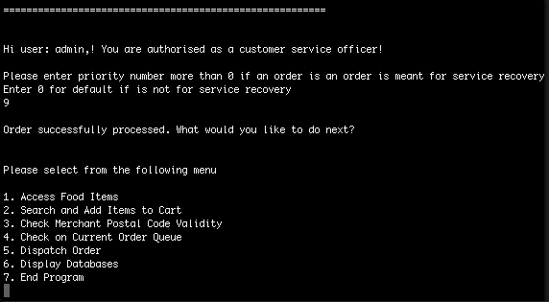

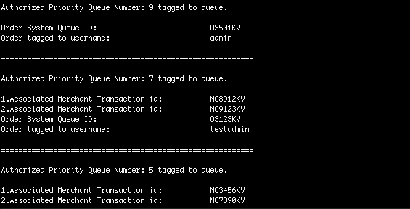

1. By regular Queue conventions. The order should have been added all the way to the bottom but because the priority was set to 9, and 9 is more than 7 (7 refers to system order OS123KV) , this order that you just created will be the first to be dispatched.
2. To ensure that the priority queue is really working, you can repeat the process of searching for something, updating your cart and checking out again with priority 0 as index. If you do that, you can find that your second checkout order, has created a queue right at the bottom of the existing queue list

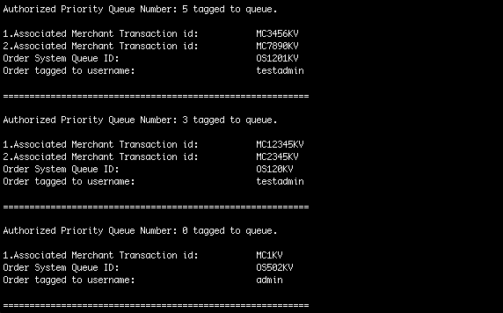

1. Now that the priority queue is working, we can emulate a queue being removed as soon as a delivery rider or partner is able to commit to the food delivery. We can do that by using option 5

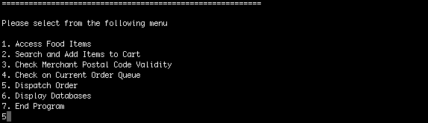

1. Once an order has been dispatched, the queue that has the highest priority index in line will be removed automatically. We can verify that, that is true by going back to option 4 to check

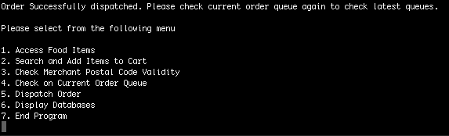

1. Once successfully removed; the order (queue) that we created with priority 8 or 9 (depending on what you chose) will disappear

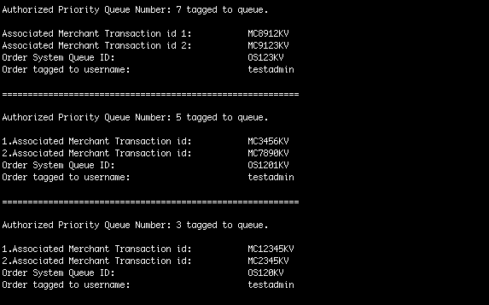

1. You can also access the orders that have been made on the application from menu option number 6. From this option, you can find ways to view and even export to .json files.

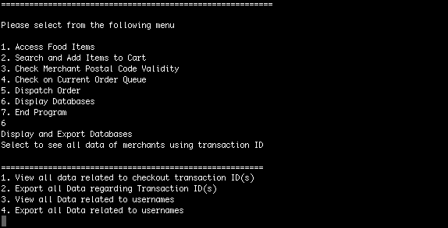

1. Last but not least, the application can also be used to check on postal code validity of a merchant. You try it out by going to option 3 and typing the following value: 520393

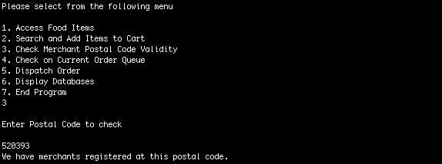

1. Feel free to check for other postal codes. This feature has been created for the sales team; primarily for them to make a quick look up on a certain postal code if there are already existing merchants registered with us.
2. Last but not least, you can test out the panic recovery by searching for any characters that are not small case alphabets. For example, an uppercase character of C instead of c , is guaranteed to cause a panic. You can find out more about how the codes are implemented in the design document in the Error, Panic and Recovery Handling section found on page 14